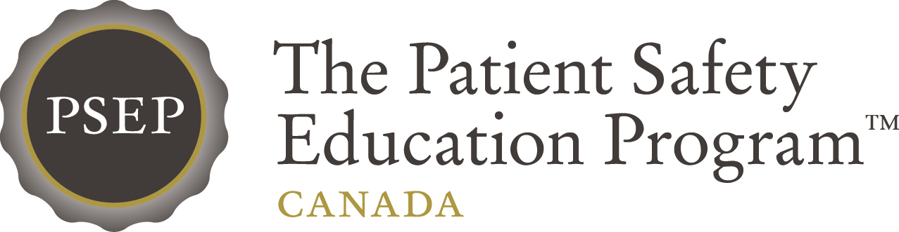

**Save the Date**

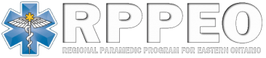[](http://www.cpsi-icsp.ca)

**For more information visit:**

[**www.patientsafetyinstitute.ca**](http://www.patientsafetyinstitute.ca)

The Canadian Patient Safety Institute (CPSI) in collaboration with the Regional Paramedic Program for Eastern Ontario (RPPEO) are pleased to announce that a Become a Patient Safety Trainer conference, a high impact, 2-day comprehensive education program will be offered in Ottawa, Ontario. This event is geared toward paramedics, physicians, and allied health providers working in or with Emergency Medical Services.

## Become a Patient Safety Trainer Education Session

## Ottawa, ON

**June 21 & 22, 2016**

Participants will leave as certified PSEP – Canada Trainers and will be equipped with a comprehensive patient safety curriculum which can be easily embedded to your organization’s current education, patient safety and quality practices.

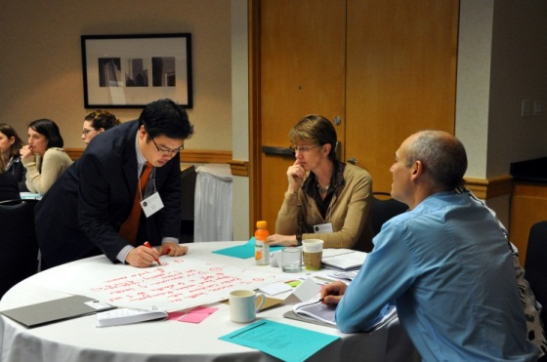 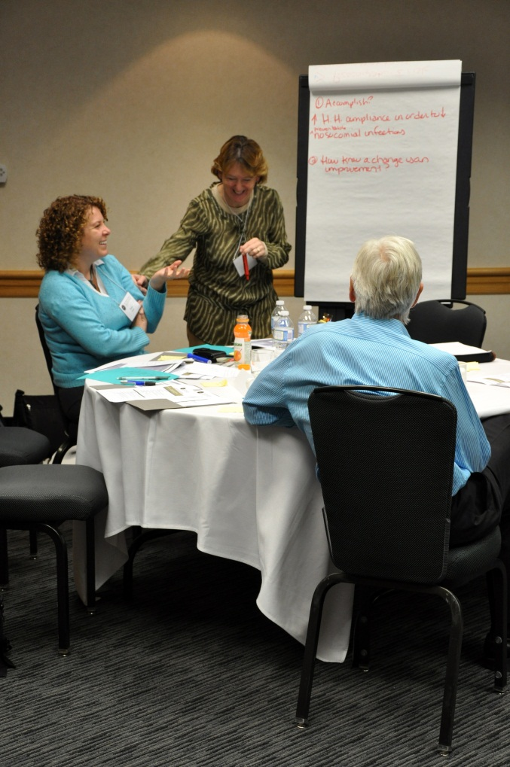

PSEP – Canada education sessions are delivered by well-respected quality and patient safety healthcare professionals and educators from across Canada and focus on **how to teach and implement patient safety** on a range of topics such as:

* Moving beyond blame to systems thinking
* Scientific methods for improving safety
* Organizational culture and dealing with change
* Understanding teamwork and communication
* Applying human factors in the workplace

